Build a Power BI Report

1.

Browse to:

<https://aka.ms/pbiSingleInstaller>

Scroll down and click download

Microsoft Power BI Desktop 
Important! Selecting a language below will dynamically change the complete page content to that language. 
Select Language: 
English 

Select 'PBIDesktopSetup_x64.exe' and click Next on bottom right

When download completes, run to begin setup

Select Next on all default values and install

2.

Click 'Got it' on first pop-up message

Click 'Get Started'

Collaborate and share 
Sign in to publish your reports, access certified 
datasets, and share insights on organizational 
content in the Power 81 service. 
Get started 
Want to buy a Power 81 license? Buy now 

Sign in as Holly@[full address]

Go to File [top right]

Save As

File name:

ServiceRequestPowerBI

Save in Documents

3.

Click Get Data (if dropdown is selected, click 'More')

Home 
X Cut 
copy 
Format painter 
Chpbærd 
ServiceRequestPower81 
Insert Modeling 
Get Excel Power BI 
data workbook datasets 

Search and select 'Sharepoint Online List'

Click Connect

Add your IT Services site - full URL beginning https://...

Type - do not copy and paste

Eg

SharePoint Online Lists 
Site URL O 
https://m365x27155673.sharepoint.com/sites/ITServ'ices[ 
Implementation 
0 20 (Beta) 
@ 1.0 
Advanced options 

Select 'Microsoft Account' and click 'sign in' - sign in as Holly

Ensure the Dropdown selection item is the complete address ending with …/ITServices

Then click 'connect'

4.

Tick the box next to 'Services Desk Requests'

Then Click 'Transform Data', NOT 'load'

x 
Navigator 
Display Options • 
P 
Services Desk Requests 
File System ObjectType 
ServerRedirectedEmbedUri 
ServerRedi rected Em bed 
• https://m365x27155673.sharepoint.com/sites/I... 
Access Requests 
appdata 
appfiles 
Composed Looks 
Converted Forms 
Documents 
Form Templates 
List Template Gallery 
Master Page Gallery 
Services Desk Requests 
Site Assets 
Site Pages 
Solution Gallery 
Style Library 
TaxonomyHiddenList 
Theme Gallery 
user Information List 
Web Part Gallery 
O The data in the preview has been truncated due to size limits. 

5.

On the Power Query Editor, scroll right to find the 'FieldValuesAsText', the click the icon on the right

Refresh 
Preview • 
Html 
Properties 
Advanced Editor 
Manage • 
Query 
Record 
Record 
Record 
Record 
Record 
Record 
Record 
Record 
Manage 
Redu 
Columns • Row 
Recort 
Record 
Record 
Record 
Record 
Record 
Record 

6.

Deselect all items on the top checkbox

ONLY select 'Customer' and 'Assign To', then OK

If these are not available, select all of the Fields options as ‘Customer’ and ‘Assign To’ will be one of these

Search Columns to Expand 
(Select All Columns) 
ContentTypeId 
O Title 
OData ModerationComments 
ComplianceAssetId 
Date 
issueTItIe 
Description 
Location 
Customer 
Assig n To 
use original column name as prefix 
List may be incomplete. 
Load more 
Cancel 

7.

Click the icon 'Close & Apply'

Close & 
Apply • 
Close 
New 
Source • 
Recent 
Sources • 
Enter 
Data 
New Query 
Queries (1) 
Services Desk Requests 

8.

Rename tab 'Page 1' to 'Service Request Tickets'

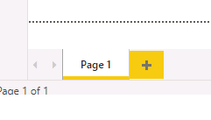

9.

On the Visualizations' tab on the right, select the 'table' icon

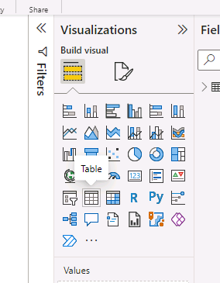

10.

On the Fields pane on the right, open the dropdown for 'Services Desk Requests'

Tick the following:

Created

FieldValuesAsText.Customer

FieldValuesAsText.AssignTo

issueTitle

Location

Title

Zxt.Cus... v X 
Zxt.Assi... v X 
ests'[Locationl 
Fields 
P Search 
*Services Desk Requests 
Assign Told 
AssignToStringId 
Attachments 
Author' d 
ComplianceAss... 
ContentTypeId 
Customerld 
CustomerString... 
Date 
Description 
Editorld 
FieldVaIuesAsT... 
FieldVaIuesAsT... 
FileSystemObJe... 
GUID 
issueT•tIe 
Location 

11.

Change the size of the table by dragging it diagonally down to the bottom right:

Paste 
Format pzinter 
3/20/2022 
xncv2022 
xncv2022 
xncv2022 
xncv2022 
xncv2022 
încv2D22 
xncv2022 
Get Excel Power BI 
data 
SQL 
Server 
Enter 
data 
Dataverse Recent 
sou rces 
Email 
o Email 
Transform Refresh 
data 
workbook datasets 
Avan 
MOD 
MOD 
MOD 
MOD 
MOD 
MOD 
MOD 
MOD 
MOD 
MOD 
MOD 
MOD 
MOD 
MOD 
MOD 

12.

The Values in Visualizations pane the can be re-ordered as desired by dragging and dropping

Visualizations 
Build visual 
Va Iues 
Created 
FieldVaIuesAsText.Cus... v X 
FieldVaIuesAsText.Assi... v X 
issueTItIe 
Title 

13.

Rename the following Values by clicking their dropdown arrow and selecting 'rename for this visual'

FieldValuesAsText.Customer - rename to **Customer**

FieldValuesAsText.Assignto - rename to **Assigned To**

issueTitle - rename to **Issue Title**

Title - rename to **Issue Status**

**So it looks as follows:**

Va Iues 
Created 
Customer 
Assigned To 
Issue Title 
Issue Status 
Drill through 

14.

Create a second visualization:

Deselect the table on the main window by clicking on white space

Format painter 
data workbook 
datasets 
Server 
Enter 
data 
sources 
data 
visual 
box 
visuals 
Clip tuns 
300/2022 
no/2D22 
Jncv2022 
no/2D22 
Jncv2022 
no/2D22 
Jncv2022 
no/2D22 
Jncv2022 
no/2D22 
Jncv2022 
no/2D22 
Jncv2022 
no/2D22 
Jncv2022 
no/2D22 
allan 
MOO 
MOO 
MOO 
MOO 
MOO 
allan 
MOO 
MOO 
MOO 
MOO 
Email 
Email 
Email 
why is my 
why is my 
Mi„irs 

15.

In the Visualizations pane, select ' Stacked column chart' (1st row, 2nd column).

visualizations 
Stacked column chart 
Build visual 
R Py 囗 
「 CD ◎ 
Fields 
、 sear 

16.

Adjust the chart accordingly:

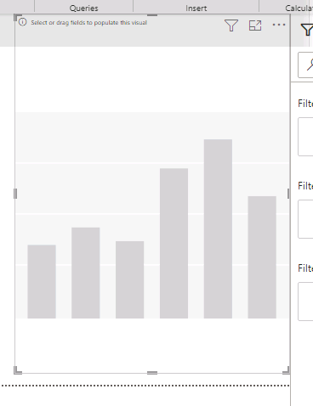

17.

In the Fields pane, tick 'Location' - this should then appear in the Axis field in the bottom the visualizations pane. If it doesn't, then drag 'Location' to the 'Axis' field:

Axis 
Location 
Legend 
Add data fields here 
Va Iues 
Add data fields here 
FieldVaIuesAsT... 
FileSystemObje... 
GUID 
issueT•tIe 
Location 
Modified 

18.

Select 'Title' in the Fields pane. When it appears under the Legend field in the Visualizations pane, rename it to 'Issue Status'

Location 
Legend 
Values 
Add data fi here 
Small mu p 
Adddatafiebdshere 
ㄒ 00 p 
囗 
囗 
囗 
囗 
囗 
囗 
囗 
囗 
FieldVabuesAsT„ 
Fi u , T. ” 
FileSystemObje•• 
GUID 
issueTitle 
Mod 
00 , 一 u Ⅳ , … 
ServerRedirect.„ 
ServerRedirect … 

19.

In the Fields pane, drag Title to the Values (Y-axis) field in the Visualizations pane:

Va Iues 
Count of Title 
Small multiples 
Add data fields here 
Tooltips 
Location 
Modified 
OData IJIVersi... 
Server Redirect.. 
ServerRedirect... 
Title 

20.

Rename 'Count of Title' to 'Count of Issue Status'

21.

Make sure the stacked chart is still selected. Click on the Format button in the 'Visualizations' pane

sitivity 
Publish 
rö Visualizations 
Format visual 
P Search 
Visual General 
Fields 
P Search 

22.

Open the dropdown for Legend, Change the Position from Top to Right center

> Y-axis 
v Legend 
v Options 
Position 
Right center 

23.

Toggle the 'Data labels' to ON

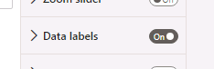

24.

Within the Visualizations pane, select the 'General' tab and open the dropdown for 'Title'

Visualizations 
Format visual 
Search 
Visual General 
> Properties 
v Title 
Text 

Make the following changes:

Enter **Ticket Count by Location and Issue Status** in the **text** field.

Scroll down to the **Text color** option and select the color of your choice for the Title.

Scroll down to the **Horizontal alignment** option. The **Left**-aligned icon is currently selected. Change this by selecting the **Center**-aligned icon.

v Title 
Text 
Ticket Count by lace 
Heading 
Heading 3 
Font 
Text 
Background 
Horizontal alignment 
Text wrap 

25.

Open the Effects dropdown in the Visualizations pane, toggle the Visual border to ON

Select a colour

v Visual border 
Color 

26.

In the Fields pane, drag 'FieldValuesAsText.Customer' to 'Add data fields here' under 'Filters on this page':

Location 
is (All) 
Add data fields here 
Filters on this page 
Add data fields here 
Filters on all pages 
Add data fields here 
Axis 
Location 
Legend 
Issue Status 
Va Iues 
Count of Issue Status 
Small multiples 
Add data fields here 
Tooltips 
Description 
Editorld 
FieldVaIuesAsT... 
FieldVaIuesAsT... 
FileSystemObJe... 
GUID 
issueT•tIe 
Location 
Modified 
OData IJIVersi... 
Server Redirect.. 
ServerRedirect... 
Title 

Test the filters

27.

In the Fields pane, drag 'Title' to 'Add data fields here' under 'Filters on this page':

Filters on this page 
FieldVa IuesAsText.C... 
is (All) 
Filter type O 
Basic filtering 
Search 
Select all 
Alex Wilber 
Diego Siciliani 
Isaiah Langer 
Joni Sherman 
Lynne Robbins 
Require single selection 
Add data fields here 
Filters on all pages 
5 
Axis 
Location 
Legend 
Issue Status 
Va Iues 
Count of Issue Status 
Small multiples 
Add data fields here 
Tooltips 
ComplianceAss... 
ContentTypeId 
Created 
Customerld 
CustomerString... 
Date 
Description 
Editorld 
FieldVaIuesAsT... 
FieldVaIuesAsT... 
FileSystemObje... 
GUID 
issueT•tIe 
Location 
Modified 
OData IJIVersi... 
ServerRedirect... 
ServerRedirect... 
Title 

Test the filters